COMP1003: Algorithms, Data Structures and Mathematics
Algorithms Practical - Graphs
SOLUTIONS

1) a) Draw the graph of 6 nodes with the following adjacency matrix.

public int[,] g = { {0, 1, 0, 1, 0, 0},
{0, 0, 0, 0, 0, 1},
{0, 0, 0, 0, 0, 0},
{0, 0, 1, 0, 1, 0},
{1, 0, 0, 0, 0, 1},
{0, 0, 1, 0, 0, 0} }; // adjacency matrix

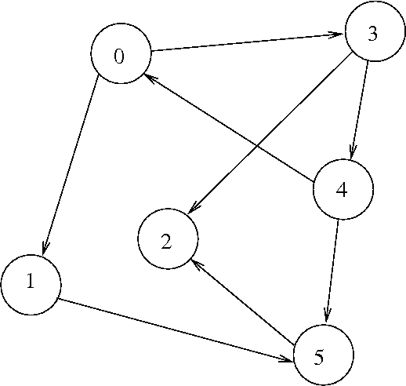

b) Draw the weighted graph with the following weight matrix

public int[,] g = { {0, 2, 0, 1, 0, 0},
{0, 0, 0, 0, 0, 4},
{0, 0, 0, 0, 0, 0},
{0, 0, 5, 0, 2, 0},
{1, 0, 0, 0, 0, 1},
{0, 0, 1, 0, 0, 0}}; // weight / distance matrix

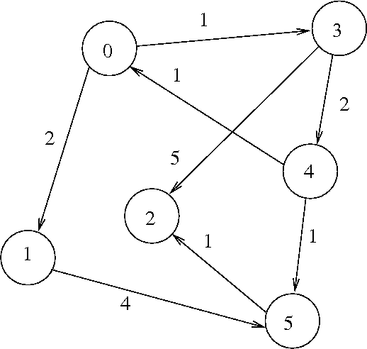
2) Depth-first graph traversal

a) Run the code; indicate the order of traversal in the picture of the graph from 1a) . Why is this "depth first traversal"?

The red numbers at the nodes in the graph below indicate the order in which nodes are visited. The order of the node numbers is depicted on the right.

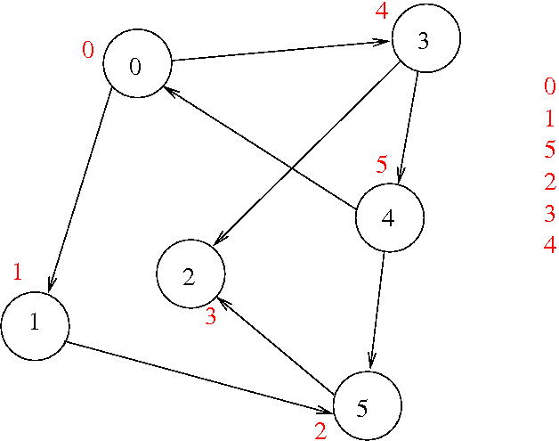
The algorithm is called "depth-first" because it first follows down paths as deeply as it can, e.g., 0>1>5>2, until this is no longer possible because there is no outgoing edge that leads to a node that has not yet been visited. Only then backtracks it and tries children of previously visited paths.

b) Draw a structogram of the traversal routine.

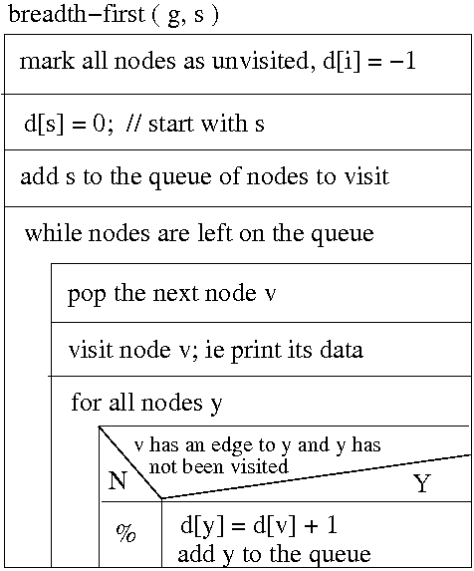
3) Bellman Ford algorithm

a) Run the code and check the returned "shortest?" paths from node 0 to the other nodes against the picture of the graph in 1b).

The picture below shows in bold red the edges of the graph that belong to the minimal "spanning tree"; this is the minimum set pf edges that contain all shortest paths from s to the other nodes. Following these paths from s=0 to the other nodes provides the shortest distances indicated on the right.

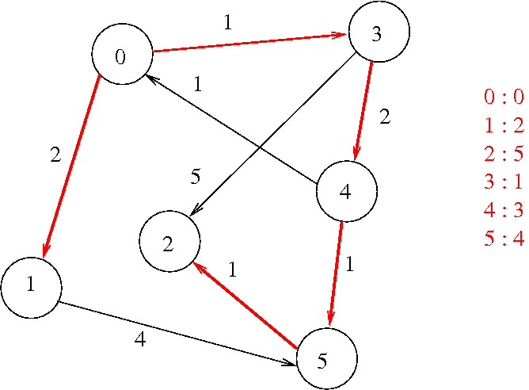
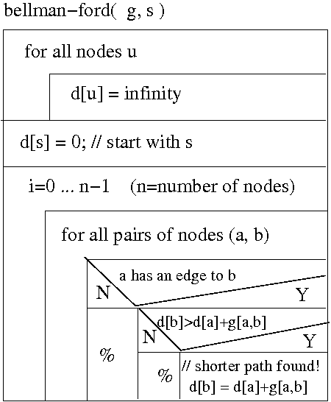

b) Compare the structogram with the implementation and identify the different parts.

nothing much to write here

4) For the experts: Breadth-first graph-traversal

a) Run the code and indicate the traversal order in the picture of the graph from 1a). Compare with the result from 2a).

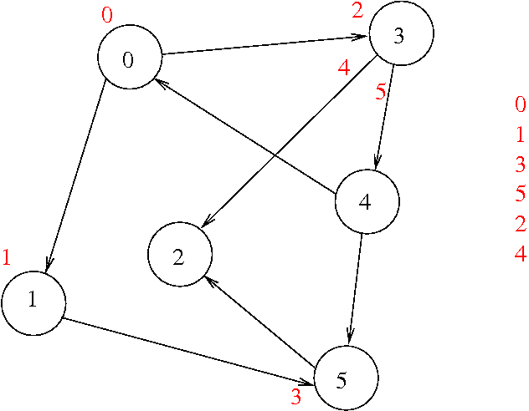

The algorithm is called "breadth-first" because it first processes all nodes on one level of depth, and puts all children of the visited nodes on a queue. These are the nodes to be processed on the next level, where again they are all processed and their children put at the end of the queue again (unless they have already been processed on an earlier level).

b) Compare the structogram with the implementation and identify the different parts.

nothing much to write here

